**Wave Nature of Light Practice Problems**

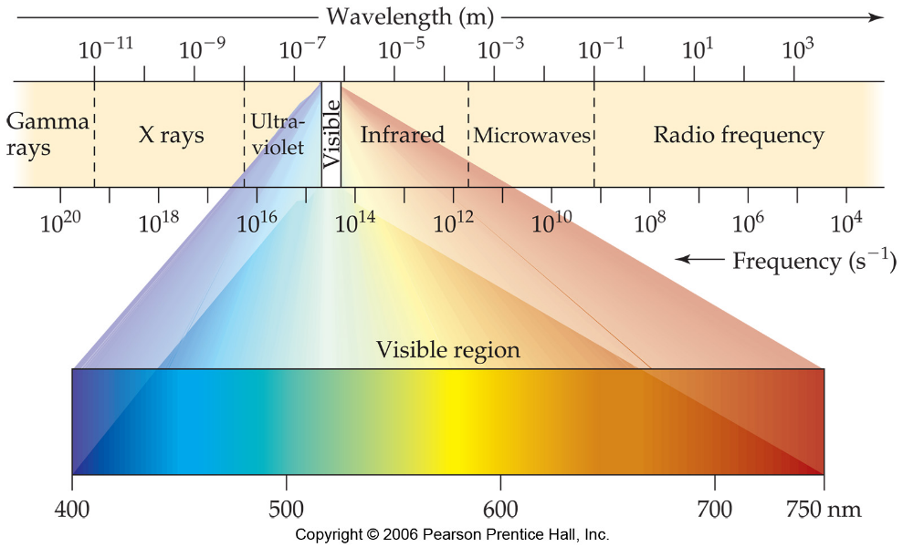

1. (a) What is the relationship between the wavelength and the frequency of radiant energy?

(b) Ozone in the upper atmosphere absorbs energy in the 210-230 nm range of the spectrum. In what region of the electromagnetic spectrum does this radiation occur?

1. Determine which of the following statements are false and correct them. (a) Electromagnetic radiation is incapable of passing through water. (b) Electromagnetic radiation travels through a vacuum at a constant speed, regardless of wavelength. (c) Infrared light has higher frequencies than visible light. (d) The glow from a fireplace, the energy within a microwave oven, and a foghorn blast are all forms of electromagnetic radiation.
2. List the following types of radiation in order of increasing wavelength: (a) gamma rays (b) FM radio station at 93.1 MHz (c) AM radio station at 680 kHz (d) yellow light (e) red light.
3. (a) What is the frequency of radiation whose wavelength in 10.0 Å?

(b) What is the wavelength of radiation that has a frequency of 7.6 x 1010 s-1?

(c) What distance does electromagnetic radiation travel in 25.5 fs?

1. What is the frequency associated with 489 nm? Is this in the visible light spectrum? If so, what color?